Assessment – 2

Question 1: Mapping Data onto Aesthetics:
1. R Program to Create a Scatter Plot:
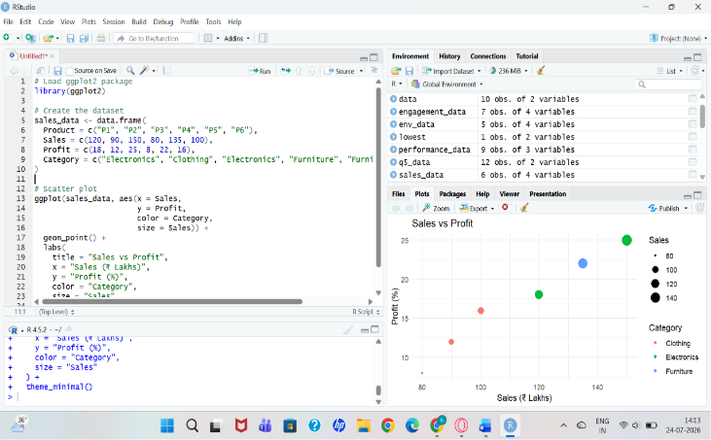
2. Mapping of Aesthetics:
- Category → Color
  - Different colors represent different product categories (Electronics, Clothing, Furniture).
- Sales → Size
  - Larger sales values are shown with larger points.
3. Interpretation of the Relationship between Sales and Profit:
- The scatter plot shows a positive relationship between Sales and Profit.
- Products with higher sales generally have higher profit percentages.
- For example:
- P3 has the highest sales (150) and highest profit (25%).
- P4 has the lowest sales (80) and lowest profit (8%).
- This indicates that as Sales increase, Profit also tends to increase.

4. Type of Scale Used for Each Variable:
Variable | Data Type | Scale Used
Sales | Numeric | Continuous Scale
Profit | Numeric | Continuous Scale
Category | Categorical | Discrete Scale
5. Alternative Visualization:
A Bubble Chart is a better alternative because it can represent:
- X-axis: Sales
- Y-axis: Profit
- Color: Category
- Bubble Size: Sales (or another variable if available)
It clearly shows the relationship between Sales, Profit, and Category in a single visualization.

Question 2: Coordinate Systems (Cartesian and Polar):
1. R Program to Visualize the Dataset Using a Cartesian Coordinate System:
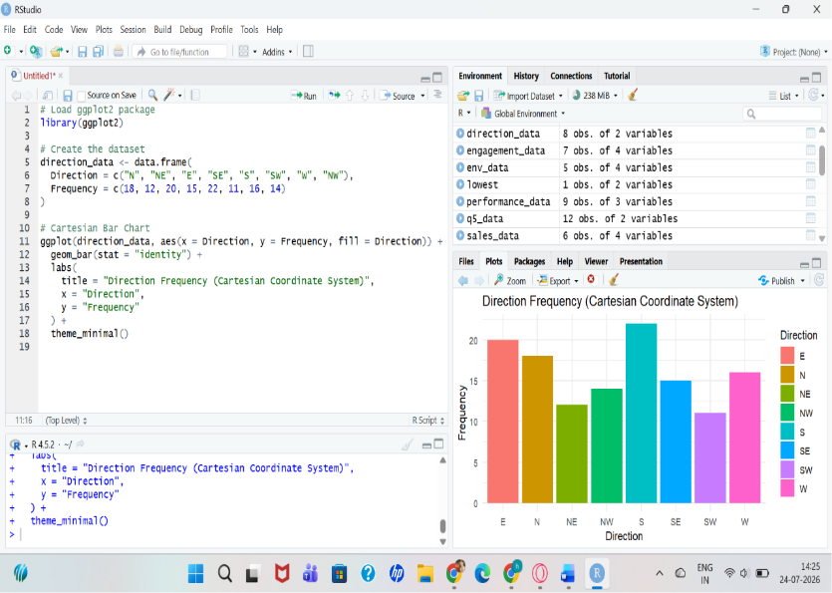

2. R Program to Visualize the Same Data Using a Polar Coordinate System:
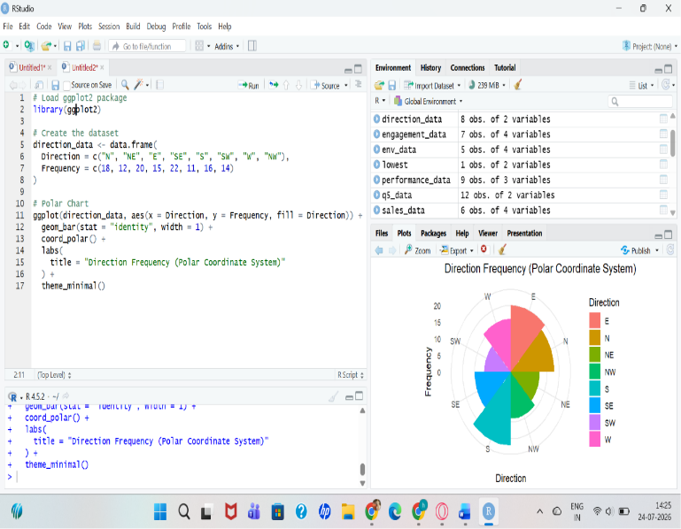
3. Compare the Effectiveness of Both Visualizations:
Cartesian Coordinate System | Polar Coordinate System

Easy to compare frequencies using bar heights. | Shows data in a circular form.

Best for comparing exact values. | Best for showing directional patterns.

Easier to read and interpret. | More visually attractive for directional data.
4. Which Coordinate System is More Appropriate for Directional Data?
The Polar Coordinate System is more appropriate for directional data because directions (N, NE, E, SE, S, SW, W, NW) naturally represent positions around a circle.
5. Justification:
- Directional data is circular in nature.
- The Polar Coordinate System represents directions in their natural order around a circle, making it easier to identify patterns.
- The Cartesian Coordinate System is better for comparing exact frequency values but does not represent the circular relationship between directions.
- Therefore, Polar coordinates provide a more meaningful visualization for directional data, while Cartesian coordinates are better for precise comparisons.

Question 3: Color Scales for Data Representation:
1. R Program to Create a Bar Chart Using a Sequential Color Scale Based on Marks: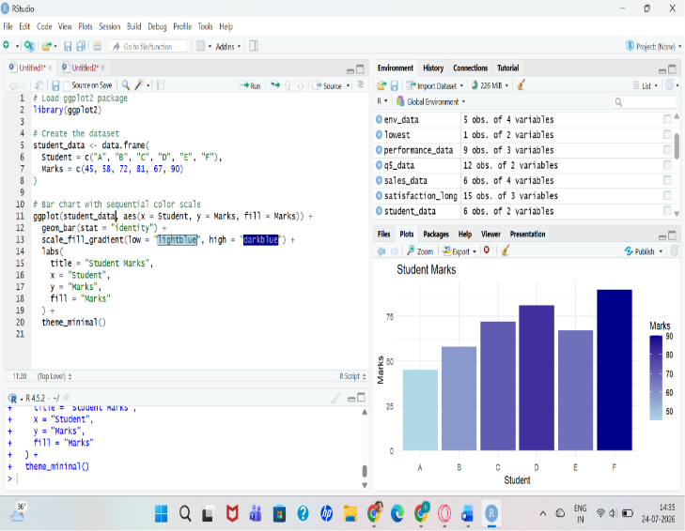

2. Identify the Students with the Highest and Lowest Marks:
- Highest Marks: Student F – 90
- Lowest Marks: Student A – 45

3. Why is a Sequential Color Scale Appropriate?
A sequential color scale is appropriate because:
- Marks are continuous numerical data.
- It uses light to dark shades to represent low to high values.
- It helps viewers easily identify students with lower and higher marks.
4. Suggest a Color Palette Suitable for Color-Blind Users:
A good color-blind-friendly palette is Viridis.
Example in R:
scale_fill_viridis_c()
Other color-blind-friendly palettes include:
- Cividis
- Plasma
- Magma
5. Difference Between Sequential and Categorical Color Scales:
Sequential Color Scale | Categorical Color Scale
Used for continuous numeric data. | Used for categorical data.
Colors change gradually from light to dark. | Each category has a different distinct color.
Shows the magnitude of values. | Distinguishes between different groups.
Example: Marks, Temperature, Sales. | Example: Gender, Department, Product Category.

Question 4: Highlighting with Color:
1. R Program to Create a Bar Chart Highlighting the Region with the Highest Revenue:
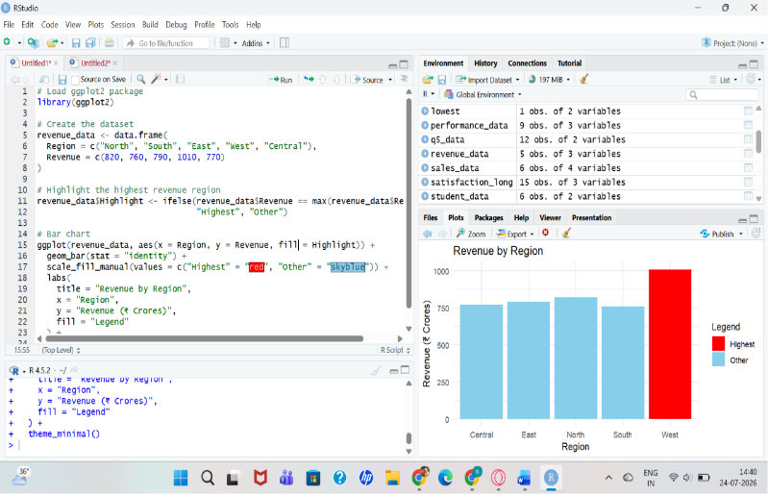

2. Explain How Highlighting Improves Data Interpretation:
- Highlighting draws attention to the most important data point.
- It helps viewers quickly identify key information without examining every bar.
- It makes comparisons easier and improves the overall readability of the chart.
3. Identify the Highest-Performing Region:
- West has the highest revenue with ₹1010 Crores.
4. Discuss How Excessive Use of Colors Can Affect Interpretation:
- Too many colors can make the chart confusing.
- It becomes difficult to identify the most important information.
- Excessive colors may distract the viewer and reduce readability.
- Using only a few meaningful colors creates a clearer visualization.
5. Suggest One Alternative Highlighting Technique Other Than Color:
One alternative highlighting technique is:
- Adding data labels to the highest bar (showing the exact revenue value).
Other alternatives include:
- Using a different bar pattern (e.g., stripes).
- Making the highest bar thicker.
- Adding an annotation or arrow pointing to the highest bar.

Question 5: Integrated Visualization:
1. R Program to Create a Bubble Chart Using Appropriate Aesthetic Mappings:
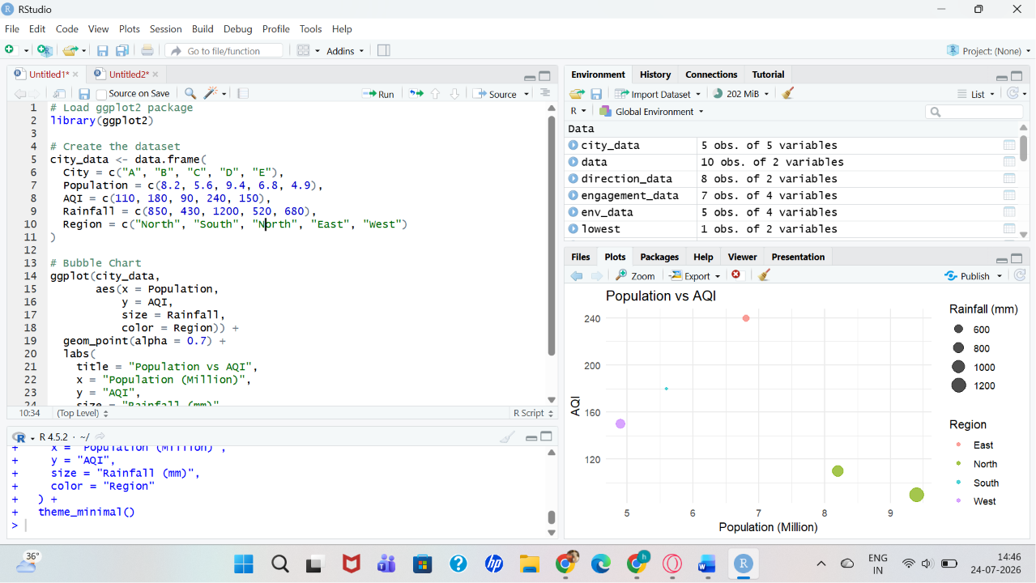
2. Suitable Aesthetic Mappings:
Variable | Aesthetic
Population | X-axis
AQI | Y-axis
Rainfall | Bubble Size
Region | Color
3. Interpretation of the Relationship Between Population and AQI:
- There is no strong positive or negative relationship between Population and AQI.
- Some cities with higher population have lower AQI, while others with moderate population have higher AQI.
- For example:
- City C has the highest population (9.4 million) but a relatively low AQI (90).
- City D has a lower population (6.8 million) but the highest AQI (240).
- This suggests that factors other than population may influence air quality.
4. Identify the Continuous and Categorical Variables:
Variable | Type
Population | Continuous
AQI | Continuous
Rainfall | Continuous
Region | Categorical
City | Categorical
5. Recommend One Improvement to Enhance the Visualization's Readability:
One improvement is to add labels for each city using geom_text() or geom_label(). This allows viewers to identify each bubble easily without referring to the dataset.
Example:
geom_text(aes(label = City), vjust = -1)
This makes the bubble chart clearer and easier to interpret.

